Chapter 4
Search in Complex Environments
In which we relax the simplifying assumptions of the previous chapter, to get closer to the real world.
Chapter 3 addressed problems in fully observable, deterministic, static, known environments where the solution is a sequence of actions. In this chapter, we relax those constraints. We begin with the problem of finding a good state without worrying about the path to get there, covering both discrete (Section 4.1) and continuous (Section 4.2) states. Then we relax the assumptions of determinism (Section 4.3) and observability (Section 4.4). In a nondeterministic world, the agent will need a conditional plan and carry out different actions depending on what it observes—for example, stopping if the light is red and going if it is green. With partial observability, the agent will also need to keep track of the possible states it might be in. Finally, Section 4.5 guides the agent through an unknown space that it must learn as it goes, using online search.
4.1 Local Search and Optimization Problems
In the search problems of Chapter 3 we wanted to find paths through the search space, such as a path from Arad to Bucharest. But sometimes we care only about the final state, not the path to get there. For example, in the 8-queens problem (Figure 4.3), we care only about finding a valid final configuration of 8 queens (because if you know the configuration, it is trivial to reconstruct the steps that created it). This is also true for many important applications such as integrated-circuit design, factory floor layout, job shop scheduling, automatic programming, telecommunications network optimization, crop planning, and portfolio management.
Local search algorithms operate by searching from a start state to neighboring states, without keeping track of the paths, nor the set of states that have been reached. That means they are not systematic—they might never explore a portion of the search space where a solution actually resides. However, they have two key advantages: (1) they use very little memory; and (2) they can often find reasonable solutions in large or infinite state spaces for which systematic algorithms are unsuitable.
Local search algorithms can also solve optimization problems, in which the aim is to find the best state according to an objective function.
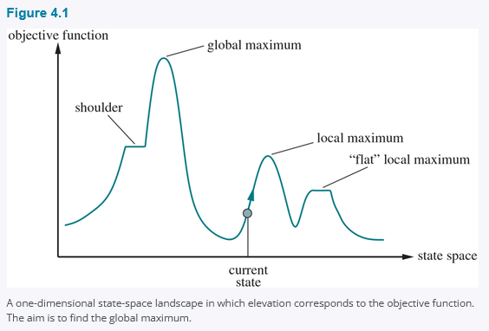
To understand local search, consider the states of a problem laid out in a state-space landscape, as shown in Figure 4.1. Each point (state) in the landscape has an “elevation,” defined by the value of the objective function. If elevation corresponds to an objective function, then the aim is to find the highest peak—a global maximum—and we call the process hill climbing. If elevation corresponds to cost, then the aim is to find the lowest valley—a global minimum—and we call it gradient descent.

4.1.1 Hill-climbing search
The hill-climbing search algorithm is shown in Figure 4.2. It keeps track of one current state and on each iteration moves to the neighboring state with highest value—that is, it heads in the direction that provides the steepest ascent. It terminates when it reaches a “peak” where no neighbor has a higher value. Hill climbing does not look ahead beyond the immediate neighbors of the current state. This resembles trying to find the top of Mount Everest in a thick fog while suffering from amnesia. Note that one way to use hill-climbing search is to use the negative of a heuristic cost function as the objective function; that will climb locally to the state with smallest heuristic distance to the goal.
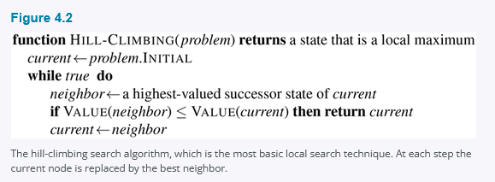

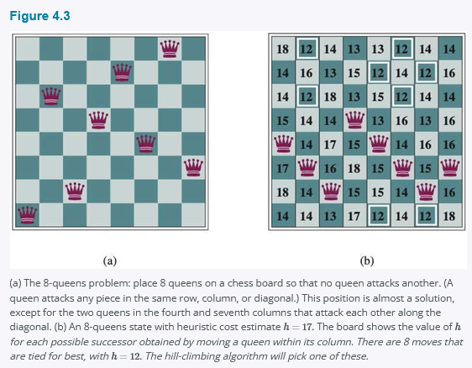
To illustrate hill climbing, we will use the 8-queens problem (Figure 4.3). We will use a complete-state formulation, which means that every state has all the components of a solution, but they might not all be in the right place. In this case every state has 8 queens on the board, one per column. The initial state is chosen at random, and the successors of a state are all possible states generated by moving a single queen to another square in the same column, so each state has 8 × 7 = 56 successors. The heuristic cost function h is the number of pairs of queens that are attacking each other; this will be zero only for solutions. It counts as an attack if two pieces are in the same line, even if there is an intervening piece between them. Figure 4.3(b) shows a state that has h = 17. The figure also shows the h values of all its successors.
Hill climbing is sometimes called greedy local search because it grabs a good neighbor state without thinking ahead about where to go next. Although greed is considered one of the seven deadly sins, it turns out that greedy algorithms often perform quite well. Hill climbing can make rapid progress toward a solution because it is usually quite easy to improve a bad state. For example, from the state in Figure 4.3(b), it takes just five steps to reach the state in Figure 4.3(a), which has h = 1 and is very nearly a solution. Unfortunately, hill climbing can get stuck for any of the following reasons:
• Local maxima: A local maximum is a peak that is higher than each of its neighboring states but lower than the global maximum. Hill-climbing algorithms that reach the vicinity of a local maximum will be drawn upward toward the peak but will then be stuck with nowhere else to go. Figure 4.1 illustrates the problem schematically. More concretely, the state in Figure 4.3(a) is a local maximum—that is, a local minimum for the cost h; every move of a single queen makes the situation worse.
• Ridges: A ridge is shown in Figure 4.4. Ridges result in a sequence of local maxima that is very difficult for greedy algorithms to navigate.
• Plateaus: A plateau is a flat area of the state-space landscape. It can be a flat local maximum, from which no uphill exit exists, or a shoulder, from which progress is possible. See Figure 4.1. A hill-climbing search can get lost wandering on the plateau.
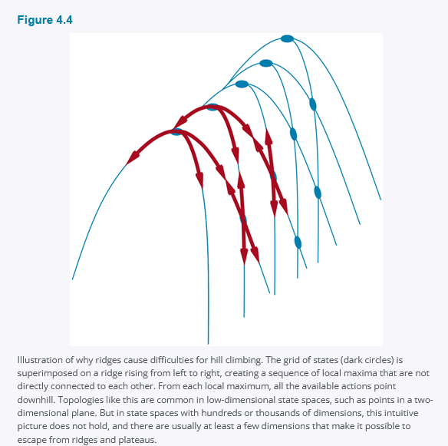
In each case, the algorithm reaches a point at which no progress is being made. Starting from a randomly generated 8-queens state, steepest-ascent hill climbing gets stuck 86% of the time, solving only 14% of problem instances. On the other hand, it works quickly, taking just 4 steps on average when it succeeds and 3 when it gets stuck—not bad for a state space with 8⁸ ≈ 17 million states.
How could we solve more problems? One answer is to keep going when we reach a plateau—to allow a sideways move in the hope that the plateau is really a shoulder, as shown in Figure 4.1. But if we are actually on a flat local maximum, then this approach will wander on the plateau forever. Therefore, we can limit the number of consecutive sideways moves, stopping after, say, 100 consecutive sideways moves. This raises the percentage of problem instances solved by hill climbing from 14% to 94%. Success comes at a cost: the algorithm averages roughly 21 steps for each successful instance and 64 for each failure.
Many variants of hill climbing have been invented. Stochastic hill climbing chooses at random from among the uphill moves; the probability of selection can vary with the steepness of the uphill move. This usually converges more slowly than steepest ascent, but in some state landscapes, it finds better solutions. First-choice hill climbing implements stochastic hill climbing by generating successors randomly until one is generated that is better than the current state. This is a good strategy when a state has many (e.g., thousands) of successors.
Another variant is random-restart hill climbing, which adopts the adage, “If at first you don’t succeed, try, try again.” It conducts a series of hill-climbing searches from randomly generated initial states, until a goal is found. It is complete with probability 1, because it will eventually generate a goal state as the initial state. If each hill-climbing search has a probability p of success, then the expected number of restarts required is 1/p. For 8-queens instances with no sideways moves allowed, p ≈ 0.14, so we need roughly 7 iterations to find a goal (6 failures and 1 success). The expected number of steps is the cost of one successful iteration plus (1 − p)/p times the cost of failure, or roughly 22 steps in all. When we allow sideways moves, 1/0.94 ≈ 1.06 iterations are needed on average and (1 × 21) + (0.06/0.94) × 64 ≈ 25 steps. For 8-queens, then, random-restart hill climbing is very effective indeed. Even for three million queens, the approach can find solutions in seconds.⁴
The success of hill climbing depends very much on the shape of the state-space landscape: if there are few local maxima and plateaus, random-restart hill climbing will find a good solution very quickly. On the other hand, many real problems have a landscape that looks more like a widely scattered family of balding porcupines on a flat floor, with miniature porcupines living on the tip of each porcupine needle. NP-hard problems (see Appendix A) typically have an exponential number of local maxima to get stuck on. Despite this, a reasonably good local maximum can often be found after a small number of restarts.
4.1.2 Simulated annealing
A hill-climbing algorithm that never makes “downhill” moves toward states with lower value (or higher cost) is always vulnerable to getting stuck in a local maximum. In contrast, a purely random walk that moves to a successor state without concern for the value will eventually stumble upon the global maximum, but will be extremely inefficient. Therefore, it seems reasonable to try to combine hill climbing with a random walk in a way that yields both efficiency and completeness.
Simulated annealing is such an algorithm. In metallurgy, annealing is the process used to temper or harden metals and glass by heating them to a high temperature and then gradually cooling them, thus allowing the material to reach a low-energy crystalline state. To explain simulated annealing, we switch our point of view from hill climbing to gradient descent (i.e., minimizing cost) and imagine the task of getting a ping-pong ball into the deepest crevice in a very bumpy surface. If we just let the ball roll, it will come to rest at a local minimum. If we shake the surface, we can bounce the ball out of the local minimum—perhaps into a deeper local minimum, where it will spend more time. The trick is to shake just hard enough to bounce the ball out of local minima but not hard enough to dislodge it from the global minimum. The simulated-annealing solution is to start by shaking hard (i.e., at a high temperature) and then gradually reduce the intensity of the shaking (i.e., lower the temperature).
The overall structure of the simulated-annealing algorithm (Figure 4.5) is similar to hill climbing. Instead of picking the best move, however, it picks a random move. If the move improves the situation, it is always accepted. Otherwise, the algorithm accepts the move with some probability less than 1. The probability decreases exponentially with the “badness” of the move—the amount ΔE by which the evaluation is worsened. The probability also decreases as the “temperature” T goes down: “bad” moves are more likely to be allowed at the start when T is high, and they become more unlikely as T decreases. If the schedule lowers T to 0 slowly enough, then a property of the Boltzmann distribution, e^(ΔE/T), is that all the probability is concentrated on the global maxima, which the algorithm will find with probability approaching 1.⁵
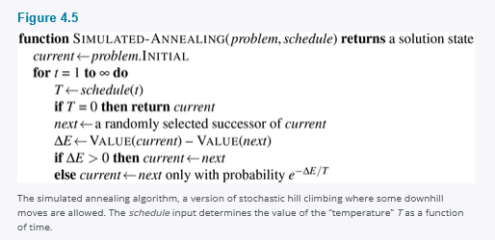
Simulated annealing was used to solve VLSI layout problems beginning in the 1980s. It has been applied widely to factory scheduling and other large-scale optimization tasks.
4.1.3 Local beam search
Keeping just one node in memory might seem to be an extreme reaction to the problem of memory limitations. The local beam search algorithm keeps track of k states rather than just one. It begins with k randomly generated states. At each step, all the successors of all k states are generated. If any one is a goal, the algorithm halts. Otherwise, it selects the k best successors from the complete list and repeats.
At first sight, a local beam search with k states might seem to be nothing more than running k random restarts in parallel instead of in sequence. In fact, the two algorithms are quite different. In a random-restart search, each search process runs independently of the others. In a local beam search, useful information is passed among the parallel search threads. In effect, the states that generate the best successors say to the others, “Come over here, the grass is greener!” The algorithm quickly abandons unfruitful searches and moves its resources to where the most progress is being made.
Local beam search can suffer from a lack of diversity among the k states—they can become clustered in a small region of the state space, making the search little more than a k-times-slower version of hill climbing. A variant called stochastic beam search, analogous to stochastic hill climbing, helps alleviate this problem. Instead of choosing the top k successors, stochastic beam search chooses successors with probability proportional to the successors’ value, thus increasing diversity.
4.1.4 Evolutionary algorithms
Evolutionary algorithms can be seen as variants of stochastic beam search that are explicitly motivated by the metaphor of natural selection in biology: there is a population of individuals (states), in which the fittest (highest value) individuals produce offspring (successor states) that populate the next generation, a process called recombination. There are endless forms of evolutionary algorithms, varying in the following ways:
• The size of the population.
• The representation of each individual. In genetic algorithms, each individual is a string over a finite alphabet (often a Boolean string), just as DNA is a string over the alphabet ACGT. In evolution strategies, an individual is a sequence of real numbers, and in genetic programming an individual is a computer program.
• The mixing number, ρ, which is the number of parents that come together to form offspring. The most common case is ρ = 2: two parents combine their “genes” (parts of their representation) to form offspring. When ρ = 1 we have stochastic beam search (which can be seen as asexual reproduction). It is possible to have ρ > 2, which occurs only rarely in nature but is easy enough to simulate on computers.
• The selection process for selecting the individuals who will become the parents of the next generation: one possibility is to select from all individuals with probability proportional to their fitness score. Another possibility is to randomly select n individuals (n > ρ), and then select the ρ most fit ones as parents.
• The recombination procedure. One common approach (assuming ρ = 2), is to randomly select a crossover point to split each of the parent strings, and recombine the parts to form two children, one with the first part of parent 1 and the second part of parent 2; the other with the second part of parent 1 and the first part of parent 2.
• The mutation rate, which determines how often offspring have random mutations to their representation. Once an offspring has been generated, every bit in its composition is flipped with probability equal to the mutation rate.
• The makeup of the next generation. This can be just the newly formed offspring, or it can include a few top-scoring parents from the previous generation (a practice called elitism, which guarantees that overall fitness will never decrease over time). The practice of culling, in which all individuals below a given threshold are discarded, can lead to a speedup (Baum et al., 1995).
Figure 4.6(a) shows a population of four 8-digit strings, each representing a state of the 8-queens puzzle: the c-th digit represents the row number of the queen in column c. In (b), each state is rated by the fitness function. Higher fitness values are better, so for the 8-queens problem we use the number of nonattacking pairs of queens, which has a value of 8 × 7/2 = 28 for a solution. The values of the four states in (b) are 24, 23, 20, and 11. The fitness scores are then normalized to probabilities, and the resulting values are shown next to the fitness values in (b).
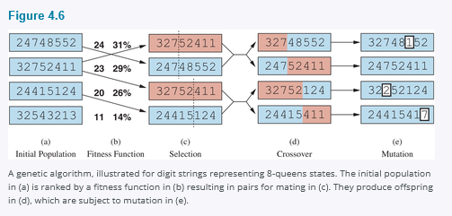
In (c), two pairs of parents are selected, in accordance with the probabilities in (b). Notice that one individual is selected twice and one not at all. For each selected pair, a crossover point (dotted line) is chosen randomly. In (d), we cross over the parent strings at the crossover points, yielding new offspring. For example, the first child of the first pair gets the first three digits (327) from the first parent and the remaining digits (48552) from the second parent. The 8-queens states involved in this recombination step are shown in Figure 4.7.
Finally, in (e), each location in each string is subject to random mutation with a small independent probability. One digit was mutated in the first, third, and fourth offspring. In the 8-queens problem, this corresponds to choosing a queen at random and moving it to a random square in its column. It is often the case that the population is diverse early on in the process, so crossover frequently takes large steps in the state space early in the search process (as in simulated annealing). After many generations of selection towards higher fitness, the population becomes less diverse, and smaller steps are typical. Figure 4.8 describes an algorithm that implements all these steps.
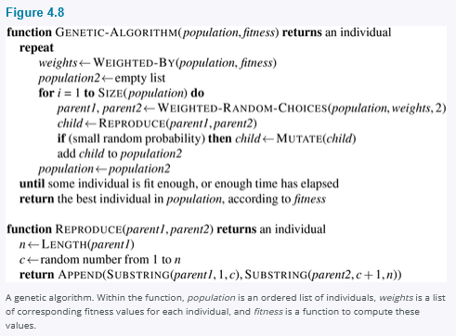
Genetic algorithms are similar to stochastic beam search, but with the addition of the crossover operation. This is advantageous if there are blocks that perform useful functions. For example, it could be that putting the first three queens in positions 2, 4, and 6 (where they do not attack each other) constitutes a useful block that can be combined with other useful blocks that appear in other individuals to construct a solution. It can be shown mathematically that, if the blocks do not serve a purpose—for example if the positions of the genetic code are randomly permuted—then crossover conveys no advantage.
The theory of genetic algorithms explains how this works using the idea of a schema, which is a substring in which some of the positions can be left unspecified. For example, the schema 246***** describes all 8-queens states in which the first three queens are in positions 2, 4, and 6, respectively. Strings that match the schema (such as 24613578) are called instances of the schema. It can be shown that if the average fitness of the instances of a schema is above the mean, then the number of instances of the schema will grow over time.
Evolution and Search
The theory of evolution was developed by Charles Darwin in On the Origin of Species by Means of Natural Selection (1859) and independently by Alfred Russel Wallace (1858). The central idea is simple: variations occur in reproduction and will be preserved in successive generations approximately in proportion to their effect on reproductive fitness.
Darwin’s theory was developed with no knowledge of how the traits of organisms can be inherited and modified. The probabilistic laws governing these processes were first identified by Gregor Mendel (1866), a monk who experimented with sweet peas. Much later, Watson and Crick (1953) identified the structure of the DNA molecule and its alphabet, AGTC (adenine, guanine, thymine, cytosine). In the standard model, variation occurs both by point mutations in the letter sequence and by “crossover” (in which the DNA of an offspring is generated by combining long sections of DNA from each parent).
The analogy to local search algorithms has already been described; the principal difference between stochastic beam search and evolution is the use of sexual reproduction, wherein successors are generated from multiple individuals rather than just one. The actual mechanisms of evolution are, however, far richer than most genetic algorithms allow. For example, mutations can involve reversals, duplications, and movement of large chunks of DNA; some viruses borrow DNA from one organism and insert it into another; and there are transposable genes that do nothing but copy themselves many thousands of times within the genome.
There are even genes that poison cells from potential mates that do not carry the gene, thereby increasing their own chances of replication. Most important is the fact that the genes themselves encode the mechanisms whereby the genome is reproduced and translated into an organism. In genetic algorithms, those mechanisms are a separate program that is not represented within the strings being manipulated.
Darwinian evolution may appear inefficient, having generated blindly some 10⁴³ or so organisms without improving its search heuristics one iota. But learning does play a role in evolution. Although the otherwise great French naturalist Jean Lamarck (1809) was wrong to propose that traits acquired by adaptation during an organism’s lifetime would be passed on to its offspring, James Baldwin’s (1896) superficially similar theory is correct: learning can effectively relax the fitness landscape, leading to an acceleration in the rate of evolution. An organism that has a trait that is not quite adaptive for its environment will pass on the trait if it also has enough plasticity to learn to adapt to the environment in a way that is beneficial. Computer simulations (Hinton and Nowlan, 1987) confirm that this Baldwin effect is real, and that a consequence is that things that are hard to learn end up in the genome, but things that are easy to learn need not reside there (Morgan and Griffiths, 2015).
Clearly, this effect is unlikely to be significant if adjacent bits are totally unrelated to each other, because then there will be few contiguous blocks that provide a consistent benefit. Genetic algorithms work best when schemas correspond to meaningful components of a solution. For example, if the string is a representation of an antenna, then the schemas may represent components of the antenna, such as reflectors and deflectors. A good component is likely to be good in a variety of different designs. This suggests that successful use of genetic algorithms requires careful engineering of the representation.
In practice, genetic algorithms have their place within the broad landscape of optimization methods (Marler and Arora, 2004), particularly for complex structured problems such as circuit layout or job-shop scheduling, and more recently for evolving the architecture of deep neural networks (Miikkulainen et al., 2019). It is not clear how much of the appeal of genetic algorithms arises from their superiority on specific tasks, and how much from the appealing metaphor of evolution.

4.2 Local Search in Continuous Spaces
In Chapter 2, we explained the distinction between discrete and continuous environments, pointing out that most real-world environments are continuous. A continuous action space has an infinite branching factor, and thus can’t be handled by most of the algorithms we have covered so far (with the exception of first-choice hill climbing and simulated annealing).
This section provides a very brief introduction to some local search techniques for continuous spaces. The literature on this topic is vast; many of the basic techniques originated in the 17th century, after the development of calculus by Newton and Leibniz.⁴¹ We find uses for these techniques in several places in this book, including the chapters on learning, vision, and robotics.
We begin with an example. Suppose we want to place three new airports anywhere in Romania, such that the sum of squared straight-line distances from each city on the map to its nearest airport is minimized. (See Figure 3.1 for the map of Romania.) The state space is then defined by the coordinates of the three airports: (x₁, y₁), (x₂, y₂), and (x₃, y₃). This is a six-dimensional space; we also say that states are defined by six variables. In general, states are defined by an n-dimensional vector of variables, x. Moving around in this space corresponds to moving one or more of the airports on the map. The objective function f(x) = f(x₁, y₁, x₂, y₂, x₃, y₃) is relatively easy to compute for any particular state once we compute the closest cities. Let Cᵢ be the set of cities whose closest airport (in the state x) is airport i. Then, we have
(4-1)
f(x) = f(x₁, y₁, x₂, y₂, x₃, y₃) = ∑ᵢ₌₁³ ∑c∈Cᵢ ((xᵢ − x_c)² + (yᵢ − y_c)²).
This equation is correct not only for the state x but also for states in the local neighborhood of x. However, it is not correct globally; if we stray too far from x (by altering the location of one or more of the airports by a large amount), then the set of closest cities for that airport changes, and we need to recompute Cᵢ.
One way to deal with a continuous state space is to discretize it. For example, instead of allowing the (xᵢ, yᵢ) locations to be any point in continuous two-dimensional space, we could limit them to fixed points on a rectangular grid with spacing of size δ (delta). Then instead of having an infinite number of successors, each state in the space would have only 12 successors, corresponding to incrementing one of the 6 variables by ±δ. We can then apply any of our local search algorithms to this discrete space. Alternatively, we could make the branching factor finite by sampling successor states randomly, moving in a random direction by a small amount, δ. Methods that measure progress by the change in the value of the objective function between two nearby points are called empirical gradient methods. Empirical gradient search is the same as steepest-ascent hill climbing in a discretized version of the state space. Reducing the value of δ over time can give a more accurate solution, but does not necessarily converge to a global optimum in the limit.
Often we have an objective function expressed in a mathematical form such that we can use calculus to solve the problem analytically rather than empirically. Many methods attempt to use the gradient of the landscape to find a maximum. The gradient of the objective function is a vector ∇f that gives the magnitude and direction of the steepest slope. For our problem, we have
∇f = (∂f/∂x₁, ∂f/∂y₁, ∂f/∂x₂, ∂f/∂y₂, ∂f/∂x₃, ∂f/∂y₃).
In some cases, we can find a maximum by solving the equation ∇f = 0. (This could be done, for example, if we were placing just one airport; the solution is the arithmetic mean of all the cities’ coordinates.) In many cases, however, this equation cannot be solved in closed form. For example, with three airports, the expression for the gradient depends on what cities are closest to each airport in the current state. This means we can compute the gradient locally (but not globally); for example,
(4.2)
∂f/∂x₁ = 2 ∑c∈C₁ (x₁ − x_c).
Given a locally correct expression for the gradient, we can perform steepest-ascent hill climbing by updating the current state according to the formula
x ← x + α∇f(x),
where α (alpha) is a small constant often called the step size. There exist a huge variety of methods for adjusting α. The basic problem is that if α is too small, too many steps are needed; if α is too large, the search could overshoot the maximum. The technique of line search tries to overcome this dilemma by extending the current gradient direction—usually by repeatedly doubling α—until f starts to decrease again. The point at which this occurs becomes the new current state. There are several schools of thought about how the new direction should be chosen at this point.
For many problems, the most effective algorithm is the venerable Newton–Raphson method. This is a general technique for finding roots of functions—that is, solving equations of the form g(x) = 0. It works by computing a new estimate for the root x according to Newton’s formula
x ← x − g(x)/g′(x).
To find a maximum or minimum of f, we need to find x such that the gradient is a zero vector (i.e., ∇f(x) = 0). Thus, g(x) in Newton’s formula becomes ∇f(x), and the update equation can be written in matrix–vector form as
x ← x − H_f⁻¹(x)∇f(x),
where H₍f₎(x) is the Hessian matrix of second derivatives, whose elements Hᵢⱼ are given by ∂²f/∂xᵢ∂xⱼ. For our airport example, we can see from Equation (4.2) that H₍f₎(x) is particularly simple: the off-diagonal elements are zero and the diagonal elements for airport i are just twice the number of cities in Cᵢ. A moment’s calculation shows that one step of the update moves airport i directly to the centroid of Cᵢ, which is the minimum of the local expression for f from Equation (4.1).⁴² For high-dimensional problems, however, computing the n² entries of the Hessian and inverting it may be expensive, so many approximate versions of the Newton–Raphson method have been developed.
Local search methods suffer from local maxima, ridges, and plateaus in continuous state spaces just as much as in discrete spaces. Random restarts and simulated annealing are often helpful. High-dimensional continuous spaces are, however, big places in which it is very easy to get lost.
A final topic is constrained optimization. An optimization problem is constrained if solutions must satisfy some hard constraints on the values of the variables. For example, in our airport-siting problem, we might constrain sites to be inside Romania and on dry land (rather than in the middle of lakes). The difficulty of constrained optimization problems depends on the nature of the constraints and the objective function. The best-known category is that of linear programming problems, in which constraints must be linear inequalities forming a convex set⁴³ and the objective function is also linear. The time complexity of linear programming is polynomial in the number of variables.
Linear programming is probably the most widely studied and broadly useful method for optimization. It is a special case of the more general problem of convex optimization, which allows the constraint region to be any convex region and the objective to be any function that is convex within the constraint region. Under certain conditions, convex optimization problems are also polynomially solvable and may be feasible in practice with thousands of variables. Several important problems in machine learning and control theory can be formulated as convex optimization problems (see Chapter 20).

